! "#$ ! !% &!&' ( )

*+,- $ . .!( $ # ! &! #$/ 0 . ( .!( & 0
1+,2# & . & -34

5 6 7898
5 8 8 9 :
- $ . . & #( & 0 . ( #( $ # ! &! #$/ 0
;-34< =>?@ABC=DE@FB@GCHDIJDKLLEFJC;44-< . ) - . #( & 0 % #(
.! " 0 . & $M #( NOPQRS+ . (0 . -34% #( .! " 0 . TUVWX%
.! #$/ 0 & $ $ (0 & RYZYW[. \WY]T^+

2 $! -34 . #( . $! _ 0&!$ . #. % /!0 . $ _! % 0
. .! & !0 0 & #( !. 0 0 ( (( + 3 $ . . ( & 0 % $
& .!0! _! & / 0 (0! . (( (( 0 & #( +

` 0 $! / &% $ !0 $ . #( & 0 . ( #(
$ # ! &! #$/ " +

‚ƒ„…f ˆ‚…•f Œf ƒ‡£f ¤ˆ‚™’…”Ÿ¥‚…•Ÿ›f

‚ƒ„…f „’„’f Œf ƒ‡£f ¤ˆ‚™’…”Ÿ§’„’Ÿ›f
abTcW^ObZd[abTQbZ\\SPQ | eUVWcY[ebSWPYW^[abTQbZ\\SPQ[  f
ghijklmhknlolpiqrqsltuhknvwlxqmyqslz{{{|f
ghijklj}j}lolpiqrqslt~}j}vwlxqmyqsl{{{€f | ¦žžž–f
f
‚ƒ„…f†‡ˆ‰ƒŠ‰ƒ‹fŒfŽf | ¨žžž–f
†‡ˆ‰ƒŠ‰ƒ‹‘’„“”ˆ‚…•–f | ‚ƒ„…f†‡ˆ‰ƒŠ‰ƒ‹fŒfƒ‡£f©‡ˆ‰ƒŠ‰ƒ‹”–f
†‡ˆ‰ƒŠ‰ƒ‹‘’„“”ˆ‚…•–f | †‡ˆ‰ƒŠ‰ƒ‹…‰˜œ‰“¤ˆ‚™’†”ª›fˆ‚…•–f
†‡ˆ‰ƒŠ‰ƒ‹‘’„“”„’„’–f | †‡ˆ‰ƒŠ‰ƒ‹…‰˜œ‰“¤ˆ‚™’†”«›f„’„’–f
†‡ˆ‰ƒŠ‰ƒ‹‘’„“”„’„’–f | †‡ˆ‰ƒŠ‰ƒ‹‘ˆ•ƒ…§“‚‘‘•ƒ‹¬ƒ­‚”–f
†‡ˆ‰ƒŠ‰ƒ‹‘’„“”„’„’–f
f
‚ƒ„…f…‚…‰—fŒf†‡ˆ‰ƒŠ‰ƒ‹f
ff˜‰‘”‘ˆ‚™’…fŒšf‘ˆ‚™’†“‰ˆ‹‰–f
ffˆ‡™’‡””‰›fœ–fŒšf‰ffœ›fž–f
f
‚ƒ„‚—‡—‚‹”Ÿ ‚…‰—fœ‰¡‰ˆ¢fŸff…‚…‰—–ff

3 . & 0 . $ # # ( 0#. & $ % 0#. #( . $ 0 0 !_ #$/ 0 /
$! . .! ! ® 0 ® 3 & &! . ! . 0#. #( . 3 & #(
& 0 + ¯ & $ .!$ 0 !0 . ! $ !& .! 0#. #( (( 0 #$/ 0%
/ & $ ' #$/ 0 $ .!$ (( 0 0 0 "! PW° ® ( .!0 ! # 0 & ® + ¯
& $ . 0 $ ' & $ #$/ " .!0 $ !0 0 & $ ± ! $ . . .!0 0
$ ' 0#& 44- $! _!&! .!$ .! (0 #( & 0 +

! "#$%&'(")*&*+",-."
/0 1

20
0 34546 76859:;<= 0
> ?
0 @ A B A C6=6DE D6F6G545HE I65= A
@ B A
@ 45C758 D6F6G545HE G:HJ58 I65=E D<=5HI: D6F6G545HE 76K;D

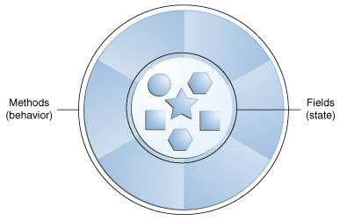
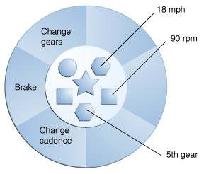L M 0 > ?

2O

L N A > ?
O P Q
R

A :H345H3:53: FK533
2S
:HT;=C54:;HU8:J:HI
O

! " "
# " "
" $" " "
" % " & "
' " "
" " " ( )"
*" " #
*" " # # " "
' + " , -
, , , '
. "
, ' '

/012345678891
/0:12345678891:1
" " "
"

; < . " = > ? (@
A < B > > (@ C . , C D E $ F " B ,
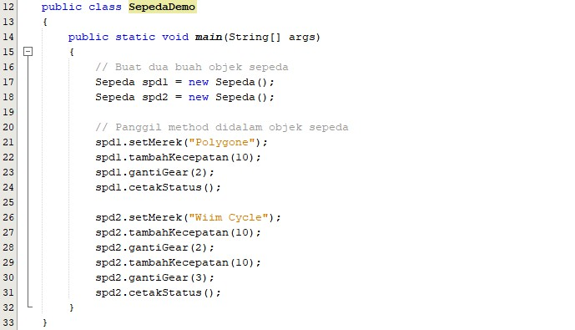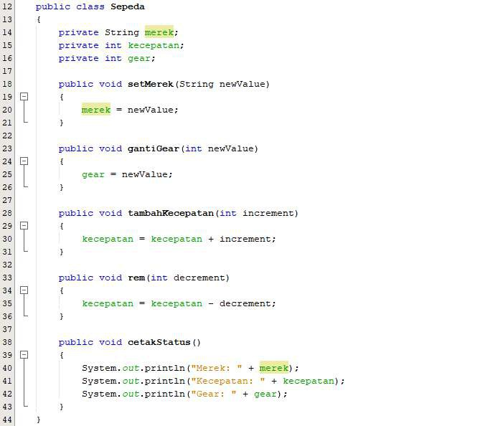
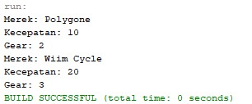

! " " " #$% !
& '()(*+,-.-./ ! " 01
2 & # ! 2 3 " " 2 ! 4
" " 56)(78-8)(.86& 9 2 3 "
1 4 2 2 3 "&

# 4 " 4 ! &

:&;< 4 '()(*+=(>?& $ '()(*+,-.-./&
@&;A (B5(.*87'()(*+7 2 3 "& C D
1 2 3 " 1 2 &

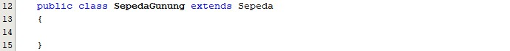
E&;C " 2 3 " F

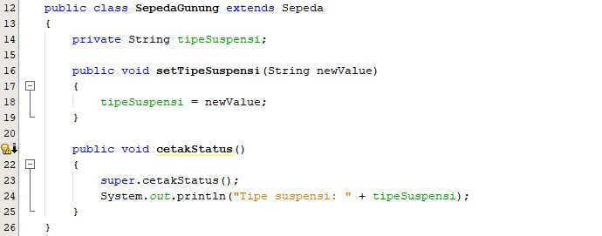
G&;C F
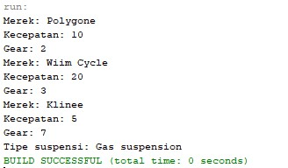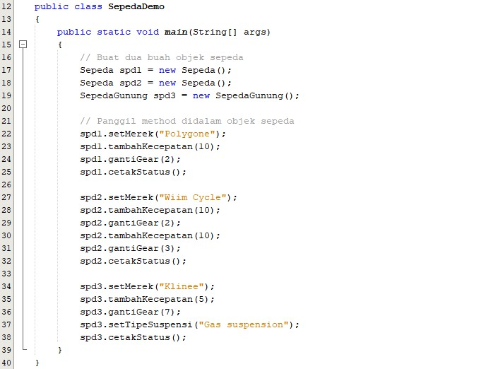

! " # $ # # % " % # ! & % " &% % & %
! # !' " % & % % # " % & % " ( # ')& #
% " % # #) * #) & # & " +,- #) ./012.34/51$ #) " %
% %!) # 6171849:/:/;

( # # ) ! < = " >) ) & " " " % " & 617184 ?% % & $
% % # $ " # % %! # $ " # % & %$ " & & $ " !@ %) "
* #) # %! #) 3.71AB:B71/B. C # # " ) % %!) # = " >) ) & " $
# 1D31/8B # ) < ' " = " $ %)" # # && # %! * #) &
! )% ! )% " " = " E #) ! +,- & # " " "
% & % # ) #)

! " ! " ! ! # ! " !
$ % # & # !& # " ! " " ! ! ! !
" " # #
' ( & ! & " # )! ! ! # # & ! # " # ! !
*+,-./01234/561578797.7873:;<
= > % ?# # @ ! # " @ @ ! ! ! # ! !
" #

A BCD E F GFCH
I # &J & ! # # K # ! #" K ! ! " ! L
M ' # & ! ! ! ! K " # K
" # ! N! & ! O@ &L # @ # !@ " # "#@ "
&! ! &#! " # "# " " ! ! "
I # " & ' # # # " # ! # " & K
P ' # & # @ # K " P & " " Q
> # ! & ! & # & ! ! &! # " " & #
# ! K " ! ! # #
R " & # ! # # # !
) R " & ! " & # # ! " # " & ! ) " !
R " & # S " ! " !
& T ! ! # # & # # !
! R ! " & # # ! K ! #
U & K & ! # ! ! ! & ! ! "
# ! #" ! !

